Restaurant Manager Assistant

User Manual

April 25, 2022

Slippery Rock University

Bradley Smith bms1040@sru.edu

Ethan Pasman eap1008@sru.edu

# Overview

To start, navigate to the homepage of the website. It should look like figure 1:

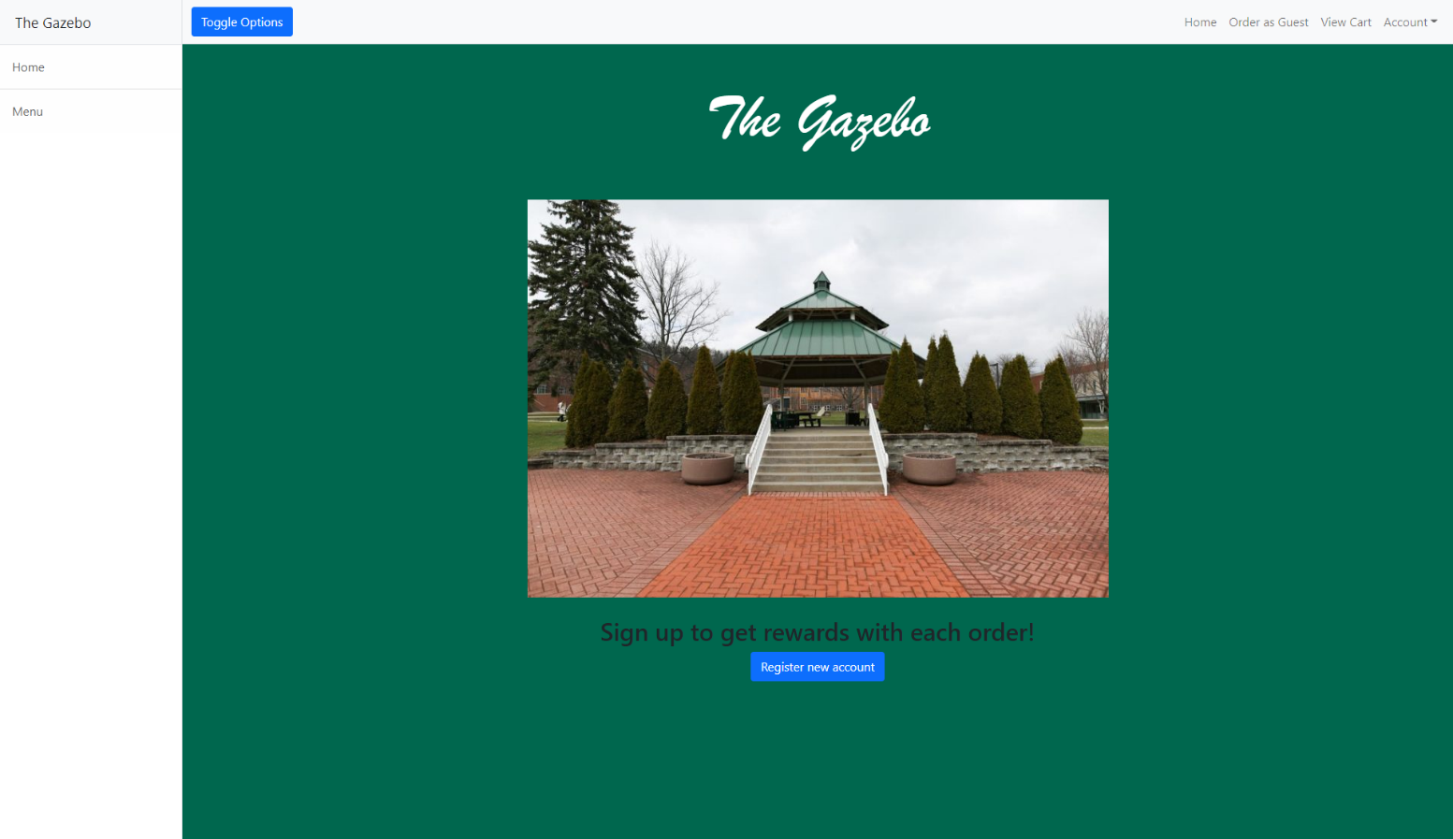

Figure 1

This is the homepage that everyone who accesses this website will start at. From here we can order as a guest, view the menu, and login. For now we will login, navigate to Account in the top Navbar and select it. Your screen should look like figure 2

Figure 2

After clicking sign-in shown in figure 2, your screen should look like figure 3

Figure 3

Here you will enter your login information. Once the information has been entered, you will be redirected to the home page of your respective role.

**NOTE: IT IS ASSUMED YOU ARE LOGGED IN FOR THE REST OF THE MANUAL AND WILL SHOW FROM THE REDIRECT SCREEN.**

# 2.Customers

Test Credentials:  
user – [customer@gmail.com](mailto:customer@gmail.com)  
pass – password

After logging into figure 3’s login page with a customer account you will be redirected to the home screen shown in figure 4.   
**NOTE: “Order as Guest” Will show as “Quick Order”. They provide the same functionality so this discrepancy can be ignored.**

Figure 4

Here we can see we have many options to choose from. We can see the menu, order as a guest, view our cart, and view our account. We will start with our order page so select the button in the highlighted area of figure 4:

Figure 5

Here Figure 5 shows the customer order screen. This is where they can select their items to add to their order. There are two buttons next to each menu item that are labeled “Add” and “Remove”(1). Clicking add will add one of the item to our cart, while clicking remove will remove one of the item. Once the customer makes their ordering choices, they can click View Cart highlighted at the bottom of figure 5 to view their cart (2):



Figure 6

Figure 6 shows the customer cart screen. Here they have multiple options to select from. They can remove items from the cart (1), write special instructions (2), pick their pickup location (3), redeem their rewards points to get discounts (4), add more items to their order (5), and checkout (6). Clicking checkout furthers the program to the payment page:

Figure 7

Figure 7 shows the payment screen. This is where the customer enters the card information to pay for their meal. They also have the option to pay with paypal above the Card Type field. Once the information is entered, select submit payment highlighted at the bottom of the figure.

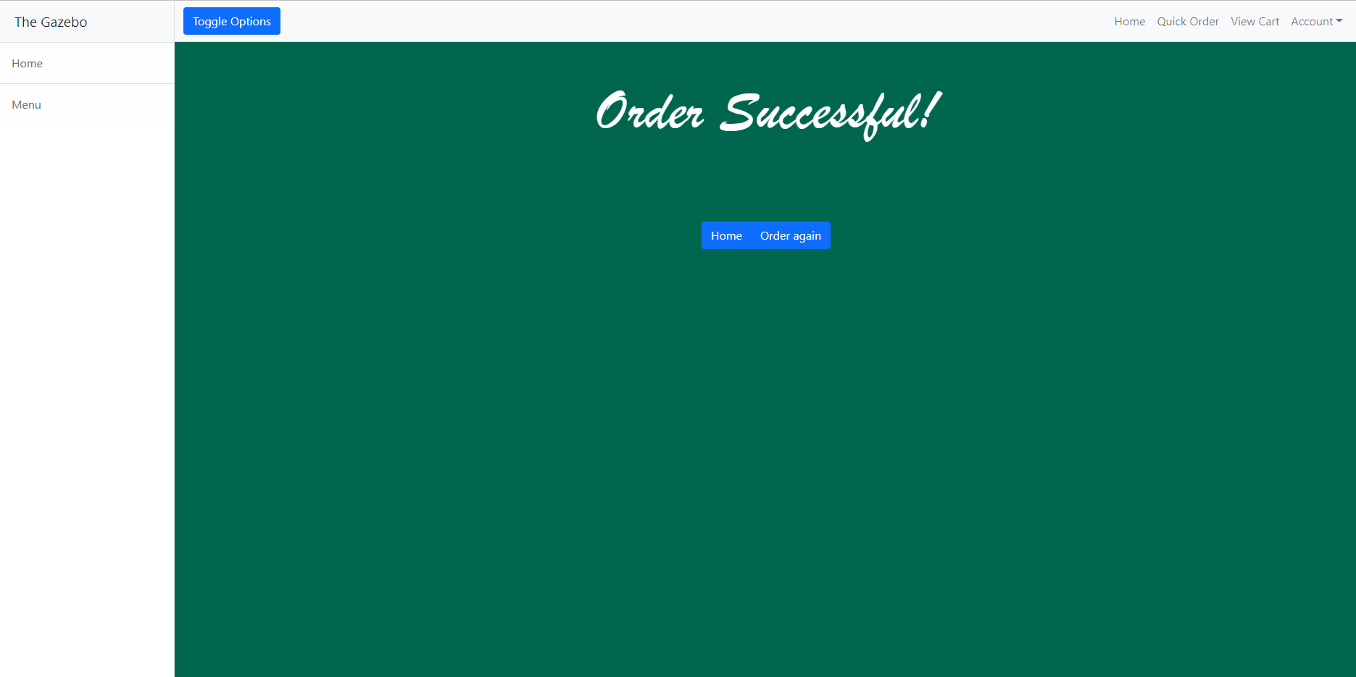

Figure 8

Here we can see the order was successful. From here we can order again or go back home. Going home will bring you back to figure 1 where we can view the menu next:

Figure 9

Select Menu:

Figure 10

Here we can see the full menu offered by the Restaurant.



# 3. Servers

Test Credentials:  
user – [server@gmail.com](mailto:server@gmail.com)  
pass – pass

Once Servers have logged in they will be redirected to this screen:

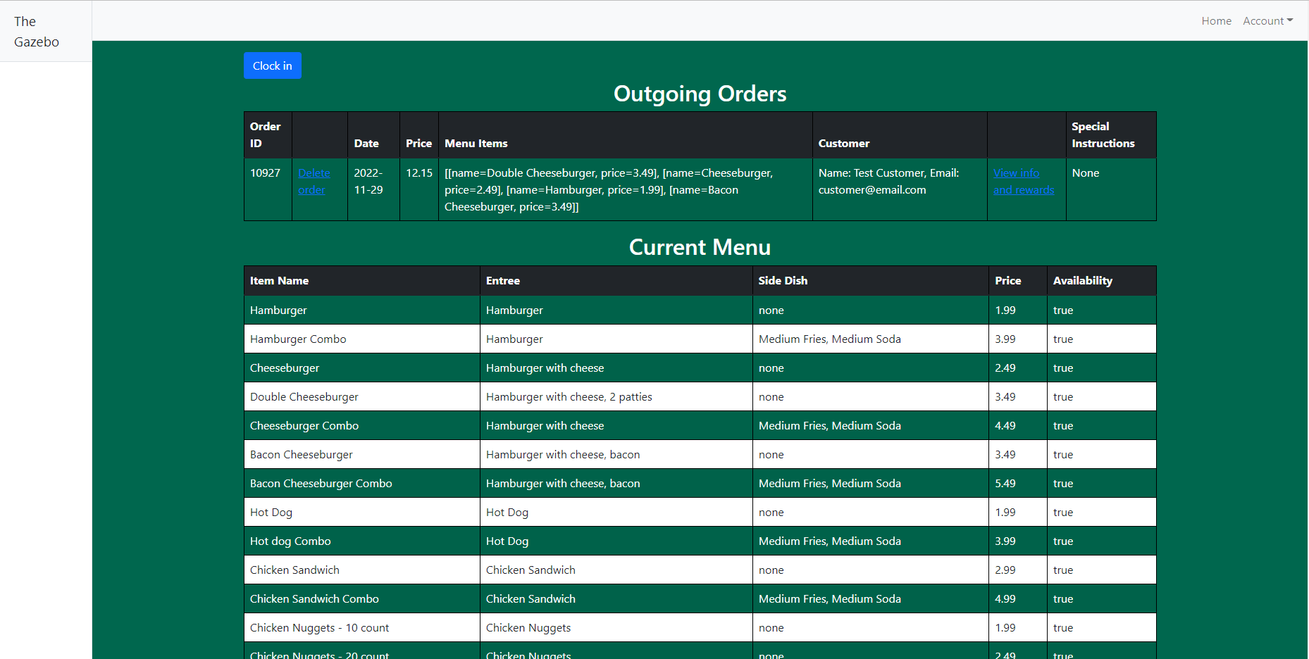

Here Servers can see the full current menu, Delete orders (which renders the order as complete, and doesn’t actually delete it), and view customer info and rewards. Select view infro and rewards highlighted in figure 11:

Figure 11

Here we can see the selected customer belonging to the order along with their rewards points.

# 4. Restaurant Managers

Credentials:  
user – [Manager@gmail.com](mailto:Manager@gmail.com)  
pass- pass

After logging in as a Restaurant Manager you will be redirected to this screen:

Figure 12

Here is the Manager Log View. Here anything that gets logged will appear. You also have the option of clocking in (1) highlighted at the top of figure 12. Navigate to the right navbar and select View Serving Staff Pages (2):

Figure 13

Figure 13 shows we can see the server view of the store. Here managers can keep track of orders. Navigate back to the navbar again and select View Customers:

Figure 14

Figure 14 shows the customers view. Here we can see all customers of the system. We can then edit or delete these customers from the database. Deleting will return the same page, but editing will show the page shown in figure 15:

Figure 15

Here we can update basic customer information. Selecting Menu from the navbar will return the same page as figure 10. Select View Servers (2):

Figure 16

Figure 16 shows the servers belonging to the logged in managers restaurant. Here we can edit or delete servers. Select Edit (1) to show the update server form:

Figure 17

Figure 17 shows the manager can change the servers name, email, hourly rate, and their weekly hours. Selecting (2) from Figure 16 returns the Inventory view:

Figure 18

Figure 18 shows the inventory view of the restaurant. It lists all ingredients and their quantity. The manager can then edit these quantities (1):

Figure 19

Figure 19 shows the update inventory screen. Here the manager can update the quantity of any inventory item. Navigate to view shipments to view all shipments belonging to the restaurant the manager is assigned:

Figure 20

Figure 20 shows all available shipments along with an option to add new shipments. Select the option highlighted in figure 20:

Figure 21

Figure 21 shows the managers form to add new shipments. They can request any amount from the available ingredients from the selected warehouse.

# 5. Warehouse Managers

Test Credentials:  
user – [WHmanager@gmail.com](mailto:WHmanager@gmail.com)  
pass – pass

After logging in with the above credentials you will be redirected to the Warehouse manager log screen shown in figure 22:

Figure 22

Select Shipments highlighted in figure 22:

Figure 23

Figure 23 shows all shipments from the warehouse that the warehouse manager is assigned. They can Accept or Deny (1) shipment requests created by Restaurant managers. These will change the status from Pending to In Progress or Declined depending on whether it was accepted or denied (2). Lastly, Select View Inventory:

Figure 24

Figure 24 shows the inventory for the warehouse the warehouse manager is assigned to. They can edit their inventory item by selecting edit in the highlighted part of figure 24:

Figure 25

# 6. Local Administrators

Test Credentials:  
user – [Administrator@gmail.com](mailto:Administrator@gmail.com)  
pass – pass

After logging in with the above credentials you will be redirected to the local admin log page shown in figure 26:

Figure 26

Select View Customers highlighted in figure 26 to show all customers:

Figure 27

Figure 27 shows three different options local admins have with customers. They can edit, delete (1), or add a new customer (2). Selecting edit will show the page seen in figure 28, while selecting new customer will show the page seen in figure 29:

Figure 28

Figure 29

Select View Managers highlighted in figure 29 to see all managers assigned to the restaurants that the admin is also assigned to:

Figure 30

Figure 30 shows the options local admins have to change local restaurant managers. They can edit, delete (1) and add new managers (2). Editing managers will show page seen in figure 31, and adding new managers will show page in figure 32:

Figure 31

Figure 32

Select View Servers highlighted in figure 32 to show all servers belonging to the list of restaurants the local admin is assigned:

Figure 33

Figure 33 shows all interactions local admin has with servers. They can edit, delete (1), and add new servers. Editing servers will show the page in figure 34, and adding new servers will show the form seen in figure 35:

Figure 34

Figure 35

Select View Employees to see all employees belonging to the list of warehouses the local admin is assigned:

Figure 36

Figure 36 shows all the interactions the local admin has with employees. They can edit, delete (1), and add new employees (2). Editing employees will show the page in figure 37, and adding new employees will show the page in figure 38:

Figure 37

# 7. HQ Manager

Test Credentials:  
user – [hqmanager@gmail.com](mailto:hqmanager@gmail.com)  
pass – pass

After logging in with the above credentials you will be redirected to the page shown in figure 38:

Figure 38

Select View Restaurant Managers highlighted in figure 38:

Figure 39

Figure 39 shows all the options available to the HQ manager for editing the local restaurant managers. They can edit, delete, and add local managers. Edit shows the page in figure 40, and Add new LF manager shows the page in figure 41:

Figure 40

Figure 40 shows all the properties the HQ manager can edit about the local restaurant manager.

Figure 41

Figure 41 shows the manager signup form for the HQ manager. Select View warehouse managers highlighted in figure 41:

Figure 42

Figure 42 shows all the information displayed to the HQ manager about the warehouse managers. They can edit, delete (1), and add new warehouse managers (2). (1) shows the page in figure 43, and (2) shows the page in figure 44.

Figure 43

Figure 43 shows the fields that are editable by the HQ manager for the warehouse manager.

Figure 44

Figure 44 shows the warehouse manager signup form to the HQ manager. Select View offices highlighted in figure 44:

Figure 45

Figure 45 shows the offices view of the HQ manager. Select View Restaurants highlighted in figure 45:

Figure 46

Figure 46 shows the Restaurants view of the HQ manager. Select View Warehouses highlighted in figure 46:

Figure 47

Figure 47 shows the Warehouses view of the HQ manager.

# 8. HQ Administrator

Test Credentials:  
user – sam  
pass – Thangiah

After logging in with the above credentials you will be redirected to the page shown in figure 48:

Figure 48

Select View Administrators highlighted in figure 48:

Figure 49

Figure 49 shows all the modifications that can be done to local administrators from the HQ admin. They can edit, delete (1), and add a new admin (2). (1) shows the page in figure 50, and (2) shows the page in figure 51:

Figure 50

Figure 50 shows all the fields that can be updated by the HQ admin. Notice that they are the only role capable of changing a password of another user.

Figure 51

Figure 51 shows the admin signup form to the HQ administrator. Select View Restaurants highlighted in figure 51:

Figure 52

Figure 52 shows all the restaurants to the HQ administrator and all modifications that can be made to that restaurant. They can edit, delete (1), and add new restaurants (2). Selecting (1) will show the page in figure 53, and selecting (2) will show the page in figure 54:

Figure 53

Figure 53 shows all the editable fields of the selected Restaurant to the HQ administrator.

Figure 54

Figure 54 shows the restaurant signup form to the HQ administrator. Select View Warehouses highlighted in figure 54:

Figure 55

Figure 55 shows all the warehouses to the HQ administrator and all modifications that can be made to that warehouse. They can edit, delete (1), and add new warehouses (2). Selecting (1) will show the page in figure 56, and selecting (2) will show the page in figure 57:

Figure 56

Figure 56 shows all the editable fields of a selected warehouse to the HQ administrator.

Figure 57

Figure 57 shows the Warehouse signup form to the HQ administrator. Select View Ofiices highlighted in figure 57:

Figure 58

Figure 58 shows all offices to the HQ administrator along with all options available to edit the offices. HQ administrators can edit, delete (1), and add new offices (2). Selecting Edit (1) shows the page in figure 59, and selecting Add new office (2) shows the page in figure 60:

Figure 59

Figure 59 shows all the modifications a HQ administrator can make to a selected office location.

Figure 60

Figure 60 shows the Office signup form to the HQ administrator.